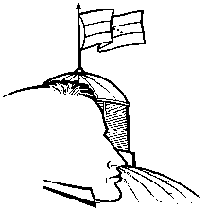
BOLIVARIAN REPUBLIC OF VENEZUELA
NATIONAL ASSEMBLY
M.P. MARÍA CORINA MACHADO
Miranda State

In Caracas, February 27th 2014

His Excellency Mr.
Michel Martelly
President of the Republic of Haiti

I address you regarding the delicate political situation that Venezuela is living in this moment, characterized by acts of unexpected violence and disrespect of human rights from the repressive forces of the national government in its attempt to silence the legitimate protest that has been taking place on a national level by the student movement and the citizens.

I am sure that as a President, you follow thoroughly the national political developments and must have watched as the student protests of the past days triggered by the brutal repression of the regional authorities of the states: Táchira, Lara, Mérida, Aragua, Anzoátegui and Miranda, as well as other entities, under false arguments and accusations had been the detonator of the student rebelliousness that it is now manifesting nationally since the last two weeks.

Likewise, you must be aware of the tragic events of the past February 12 in Caracas, when a march of unarmed students peacefully protesting was attacked by a band of vigilantes that act with impunity under the protection of the government authorities, and later, savagely repressed by police and National Guard officers. The regrettable balance of these incidents, that was three Venezuelans deceased from injuries sustained by firearms, has triggered the augmentation and prolongation of the protest in the main cities of the country. Now we must add the violent acts in several states with a balance of 15 deceased and more that 650 detained.

It won’t escape your attentive observation of the facts that this acts of disproportionate violent repression of the legitimate and explicable student protests have been accompanied, according to numerous accusations of detained victims, by unacceptable acts of torture, by an undeniable censorship of the media; and an open political persecution of leaders of the democratic opposition, against which detention measures are dictated, Leopoldo López already has a week unjustly deprived of his liberty in Ramo Verde, a jail for prosecuted military officers. The regime is getting further away from the fictional image that intends to sell abroad of a revolutionary and democratic government.

I see with increasing concern that Nicolás Maduro’s government, far from encouraging a true dialogue and act in compliance with the law and the Constitution to reestablish harmony and peace in the country, has invited to a supposedly peace conference in which, in addition to causing offence to every opposition leader and all the Venezuelans that did not choose him as a President; he refuses to admit the unconcealed violations of human rights by the Bolivarian National Police and the Bolivarian National Guard, and worse still, he congratulates the police corps for “having patience and responding decisively”. A true dialogue goes from demanding the disarmament of the armed collectives that have spread terror in the last weeks, goes from requiring the ceasing of repression and punishment to whoever is guilty of promoting and acting with violence, starting with the police and military forces.

Today we know that the government promotes a false dialogue for peace and it just seeks to win time and clean its repressive and authoritarian image before the world that has its eyes in Venezuela. It is difficult to believe in Nicolás Maduro speaking of peace in the country while paramilitary groups and police corps go out to repress thousands of demonstrators that remain in the streets exercising their constitutional right.

Venezuelan government opted for the wrong way to radicalize even more its irrational and antidemocratic conduct, by the means of more repression and persecution, as it was proved in the night of February 19, when the National Guard along the Bolivarian National Police and the termed collectives, under the cover of the mandatory broadcast in all radio and television, attacked the students and citizens present, as well as, public and private goods, utilizing firearms without discrimination against unarmed citizens and entering by force in housings without search warrants. These events continue to worsen in these days with the indiscriminate and disproportionate use of force against unarmed citizens by the National Guard and the termed collectives. There is infinite evidence that support these claims.

Given this scenario of violence and repression the government of Panamá, in accordance with the provisions of the Inter-American Democratic Charter, has requested a meeting of the Permanent Council to consider Venezuela’s situation.

Considering this, I beg you earnestly to condemn, repudiate and manifest your grievance within the framework of the Organization of American States regarding the dangerous path the political occurrences are taking in the country, the escalation of governmental repression and the inaction of governments that have among their tasks the defense of democracy and freedom in the Hemisphere.

As a part of the democratic majority of the Venezuelan people, I wish to respectfully elevate before your government my request for support of the cause of democracy and respect of human rights in the Hemisphere.

Yours sincerely
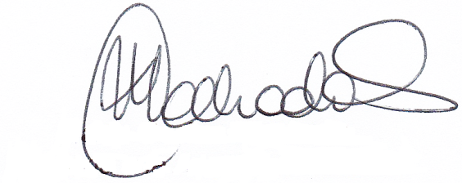

María Corina Machado
Member of the National Assembly

